Operating System Scheduling and System Responsiveness

An Assignment submitted in partial fulfillment of the requirements for the degree of
Bachelor of Science
in
Computer Science

CS 3307: Operating System 2
Term 5 - 2026
University of The People

1st July, 2026

Operating System Scheduling and System Responsiveness
This paper presents an analysis of the operating system (OS) scheduling mechanisms that impact the performance of multimedia editing applications during high-resource workloads. It addresses resource contention, the effects of multithreading and scheduling, and the role of context switching in system responsiveness. Real-world measurements from macOS Activity Monitor during a video rendering task are incorporated to illustrate key concepts, and practical recommendations are provided for improving application performance.
System resource analysis during multimedia rendering
Monitoring my system with macOS Activity Monitor while running several resource-intensive applications, including Brave Browser, IntelliJ IDEA, Claude, Microsoft Word, Grammarly Desktop, and various background services, revealed that memory usage and disk input/output (I/O) were the most strained resources, while CPU utilization remained moderate. IntelliJ IDEA consumed approximately 2.78 GB of memory, and multiple Brave Browser renderer processes collectively used several gigabytes of RAM. Out of 18.00 GB of physical memory, 13.43 GB was actively in use, and 5.72 GB of swap memory was reported. The presence of swap memory indicated that the operating system had to transfer inactive memory pages from RAM to disk due to insufficient physical memory. This swapping process significantly increases data access time, as storage devices are much slower than RAM. For example, switching between the video rendering application and Brave Browser likely required previously swapped pages to be reloaded into memory, causing noticeable freezes.
The Disk tab in Activity Monitor further supported this diagnosis. Approximately 610.24 GB of data were read, and 516.82 GB were written during the monitoring period. IntelliJ IDEA alone accounted for about 47.79 GB of disk reads, and Brave Browser exceeded 19 GB of disk reads. Such sustained disk activity suggests that the operating system was frequently performing paging operations while simultaneously handling application file access. This competition for disk resources delays video rendering because rendering software continuously reads source media and writes output files. On the other hand, CPU utilization showed comparatively low pressure. The CPU monitor reported around 89 percent idle time, with only brief spikes from Brave Browser renderer processes and Activity Monitor itself. This indicates that processor capacity was not the primary performance bottleneck. The evidence points to virtual memory management, process scheduling, and disk I/O management as the OS components most responsible for the observed performance degradation. According to Franchitti (2026), reducing the number of concurrent applications or increasing available RAM would minimize swapping, improve resource allocation, and provide smoother video rendering performance.

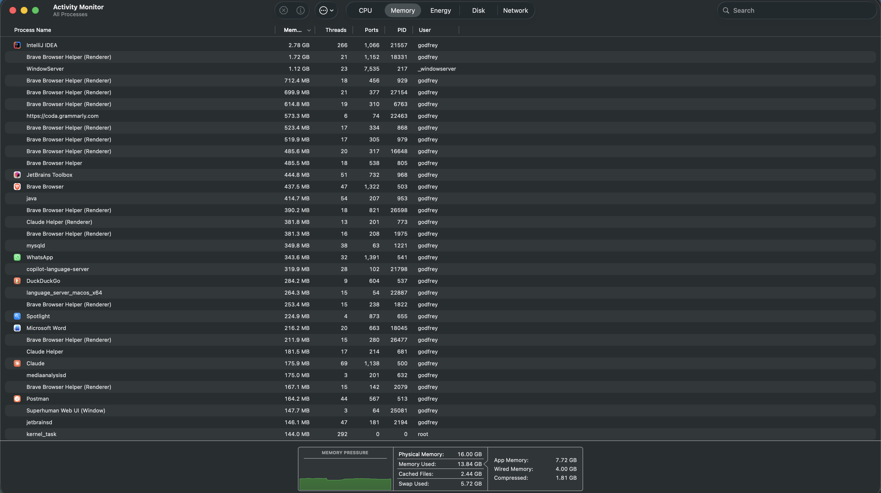
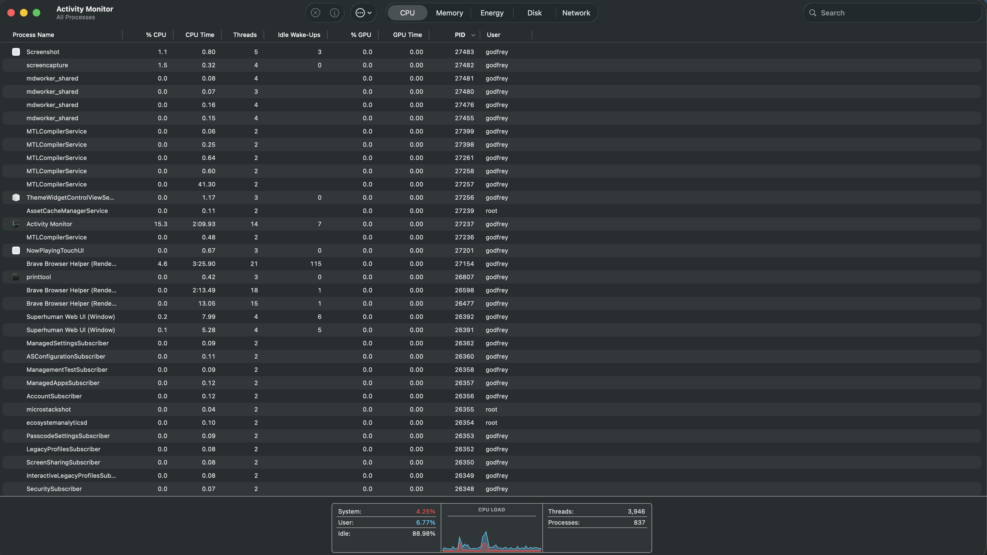

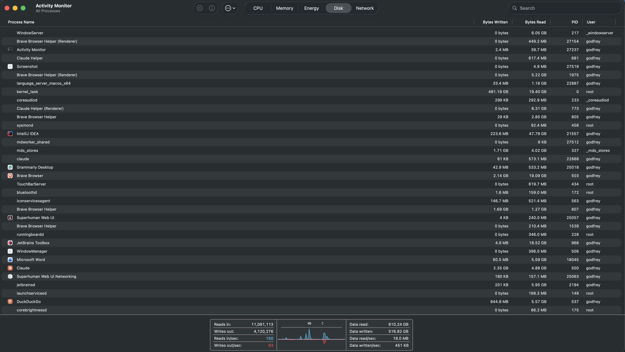
Multithreading, Scheduling, and System Responsiveness
When resource-intensive applications such as an editing tool and a browser compete for CPU time, multithreading and efficient scheduling are critical for maintaining system responsiveness. Multithreading allows applications to divide their workloads into separate threads, enabling different parts of a program to run concurrently. For example, a video editor might use one thread for encoding video frames and another for managing the user interface. This design prevents the application from freezing if a single thread is blocked by a lengthy computation or I/O operation (Franchitti, 2026). However, the effectiveness of multithreading depends on the OS scheduler. The scheduler allocates CPU time slices to threads or processes based on specific algorithms. Two approaches that can reduce contention and improve parallel processing are priority scheduling and CPU affinity.
Priority scheduling assigns a higher priority to time-sensitive tasks, such as the user interface thread of the video editor. This ensures that these threads are scheduled more frequently and are less likely to be delayed by background tasks. For instance, the OS could prioritize the video editor’s main thread over non-essential browser processes, resulting in faster response times for user actions. According to Arpaci-Dusseau & Arpaci-Dusseau (2023), such prioritization can dramatically improve perceived responsiveness even under heavy load. CPU affinity is another technique where the scheduler binds certain threads or processes to specific CPU cores. By doing so, it reduces the overhead of moving threads between cores, which can improve cache utilization and reduce context switch penalties. For example, dedicating one core to the video rendering process and another to background browser activities can prevent them from interfering with each other, thus improving overall throughput.
Load balancing is also important in multicore systems. The scheduler can distribute threads evenly across all available cores, ensuring no single core becomes a bottleneck. This strategy is particularly useful when multiple CPU-intensive tasks are running concurrently (Arpaci-Dusseau & Arpaci-Dusseau, 2023). Therefore, multithreading enables applications to remain responsive by dividing work among threads, while proper scheduling using priority assignment, CPU affinity, and load balancing ensures that critical tasks receive sufficient CPU resources even under heavy system load.
Context Switching and Its Impact on Video Rendering
To understand the impact of context switching, I used the terminal command top -l 1 | grep -E “idea|Brave|Word|claude|kernel_task|WindowServer” to gather data. The results showed that kernel_task had over 607 million context switches, WindowServer recorded over 53 million, Brave Browser’s main and helper processes accumulated more than 30 million, IntelliJ IDEA had over 15 million, and Microsoft Word and Claude each had around 3.7 million context switches.
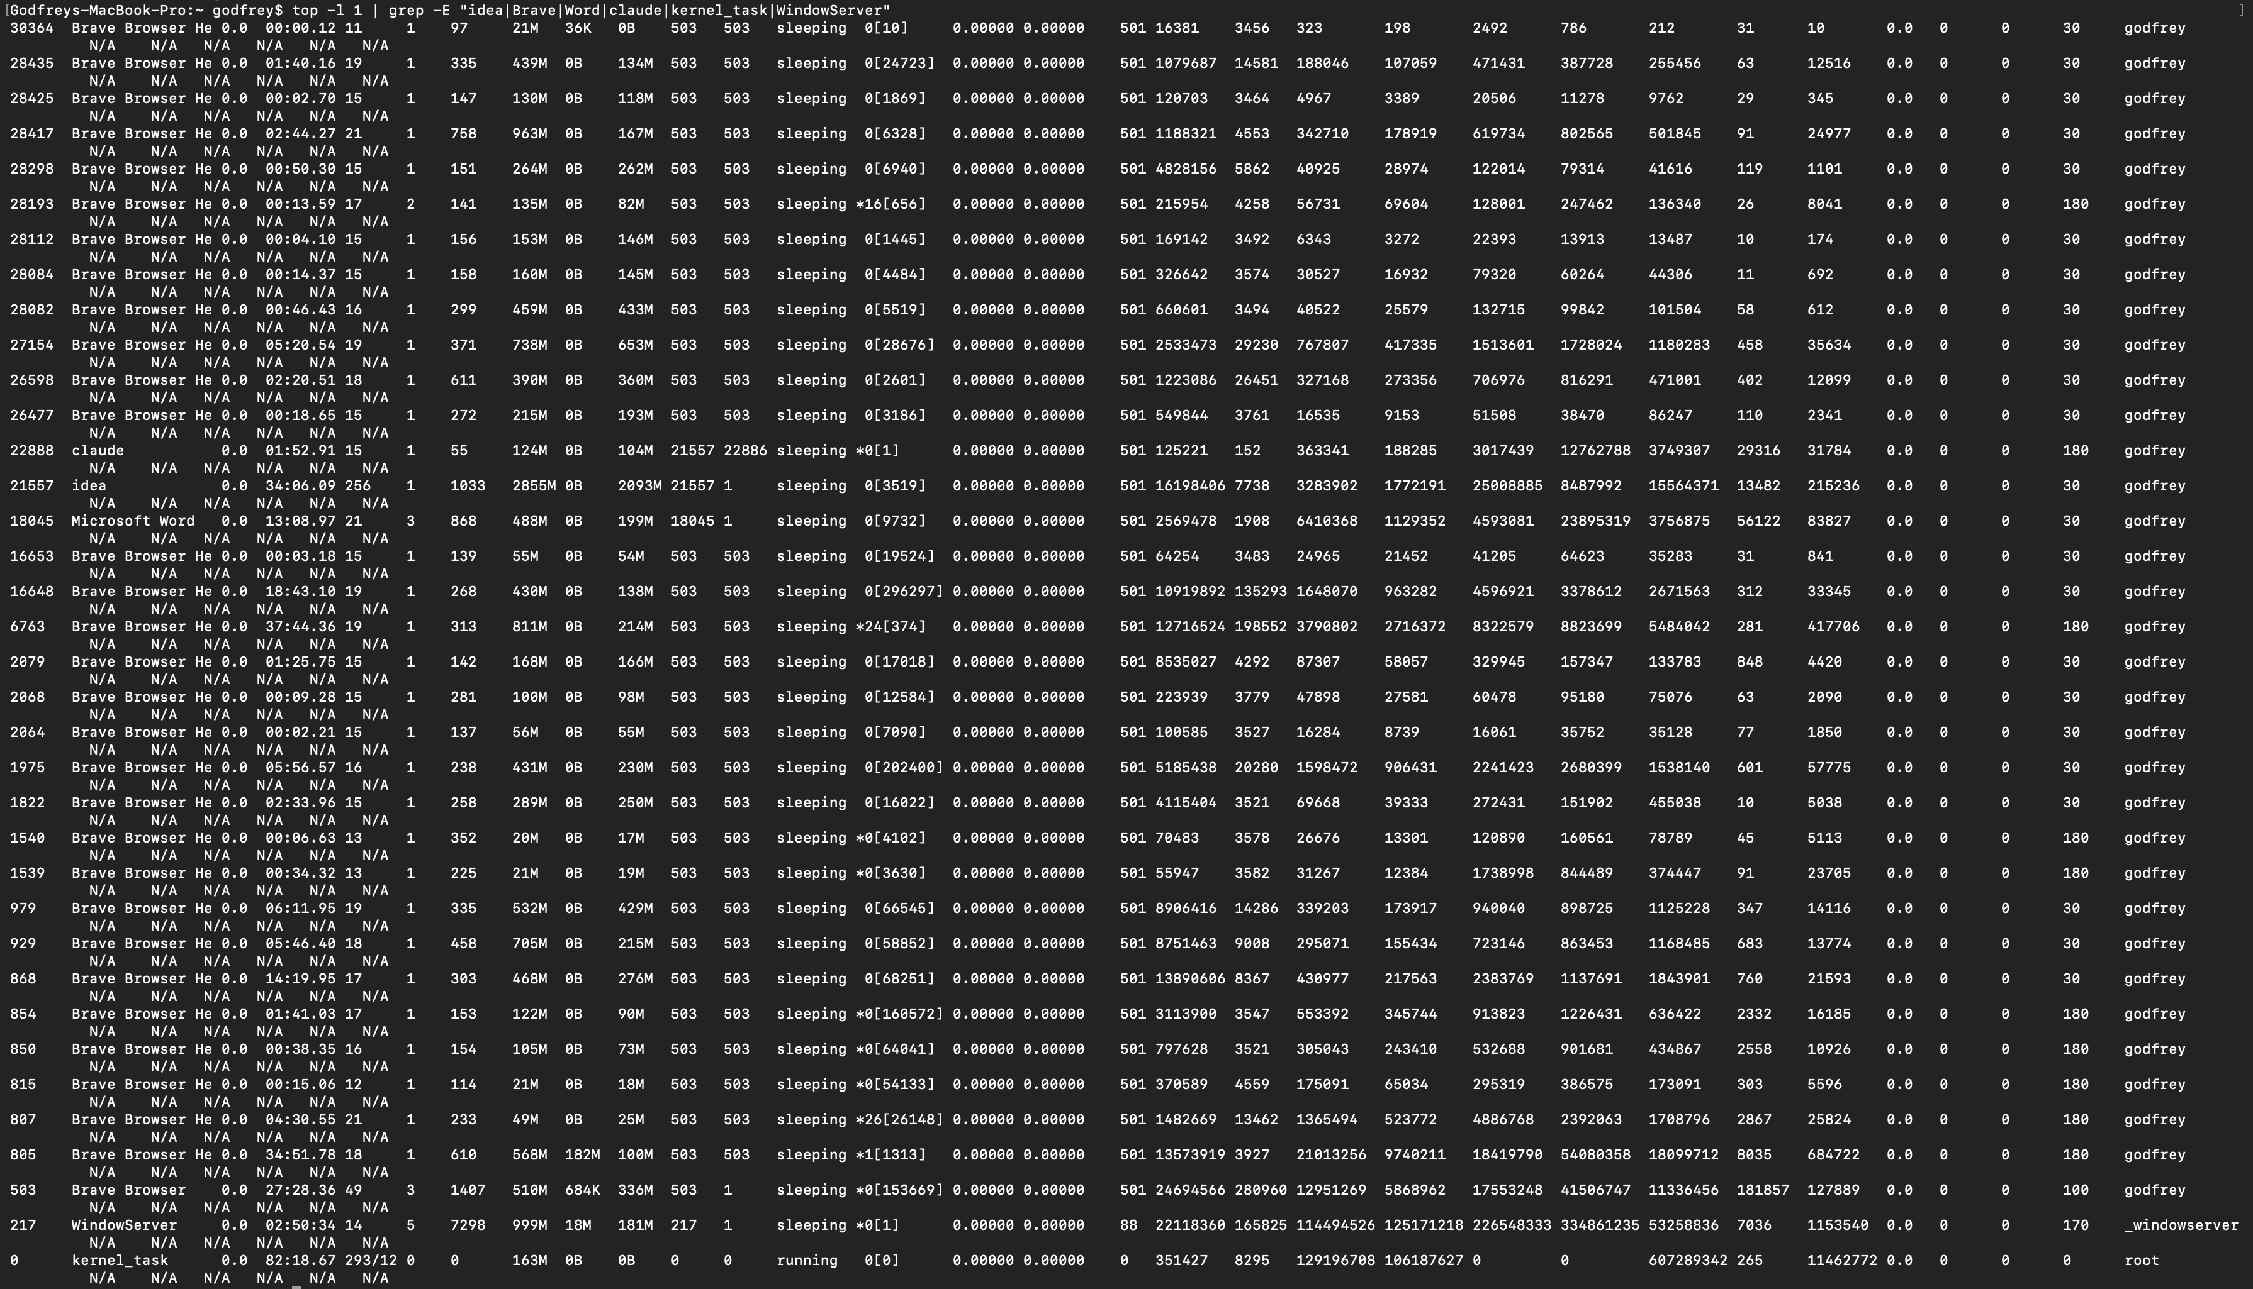
The summary of the results:
Process | Memory | Threads | Context Switches (CSW)
kernel_task | 163 MB | 293 | 607,289,342
WindowServer | 999 MB | 14 | 53,258,836
Brave Browser (main) | 510 MB | 49 | 11,336,456
Brave Browser Helper (PID 805) | 568 MB | 18 | 18,099,712
IntelliJ IDEA | 2.86 GB | 256 | 15,564,371
Microsoft Word | 488 MB | 21 | 3,756,875
Claude | 124 MB | 15 | 3,749,307

These high context switch values reveal that the OS scheduler is actively switching the CPU among many processes and threads. For example, IntelliJ IDEA used 256 threads and accumulated over 15.5 million context switches, reflecting extensive scheduling activity due to background tasks such as indexing and compilation. The Brave Browser main process and its helpers each accumulated millions of context switches because each browser tab, extension, and renderer operates as a separate process. WindowServer, which manages the graphical interface, recorded over 53 million context switches because it continuously coordinates screen updates and user interactions. Kernel_task managed over 607 million context switches due to its role in CPU scheduling, memory, interrupts, and other core OS functions.
Frequent context switching can degrade performance in several ways. Each switch requires the CPU to save the current process or thread state and load the state of the next, a process managed by the Process Control Block (PCB). This introduces execution delays and can reduce cache efficiency, as the data used by the previous task may be evicted from the CPU cache when a new task is loaded. When multiple high-demand applications run simultaneously, the increased rate of context switches means that less time is spent processing actual computations, and more time is dedicated to switching overhead (Lenovo, 2023). This can result in noticeable delays or freezes, especially during tasks such as high-resolution video rendering that require sustained, uninterrupted processing. The PCB plays a crucial role in managing competing tasks. It stores the state of each process, including the program counter, CPU registers, memory management information, and scheduling priority. When a context switch occurs, the OS saves the current state in the process’s PCB and loads the state of the next scheduled process (Franchitti, 2026). This capability enables the OS to pause and resume processes efficiently, but if context switching becomes excessive, the associated overhead can negatively impact system performance. In my measurements, despite CPU utilization being only around 9.9 percent, the OS managed 836 processes and 3,834 threads, necessitating frequent context switching. This scheduling overhead, combined with high memory utilization and extensive swapping, can delay CPU execution and contribute to application freezes during resource-intensive workloads.
Conclusion
The analysis of system monitoring data confirms that the responsiveness and stability of multimedia editing applications depend heavily on the OS’s resource management strategies. Memory and disk I/O are often primary bottlenecks, especially when swapping occurs due to insufficient RAM. Effective use of multithreading and proper scheduling policies, such as priority scheduling and CPU affinity, can enhance system responsiveness by reducing CPU contention. However, excessive context switching introduces performance overhead and can disrupt cache efficiency, particularly in environments with many concurrent processes and threads. The OS’s use of PCBs ensures accurate management of process states but cannot fully compensate for resource exhaustion. For multimedia editing applications, minimizing concurrent heavy applications, increasing available memory, and leveraging advanced scheduling strategies are essential for optimal performance.

References
Arpaci-Dusseau, R. H., & Arpaci-Dusseau, A. C. (2023). Chapter 7: CPU Scheduling. In Operating systems: Three easy pieces (Version 1.10). Arpaci-Dusseau Books.
Franchitti, J. (2026). Chapter 6.3 Processes and Concurrency. In Introduction to computer science. OpenStax.
Lenovo. (2023, May 28). How context switching helps your CPU juggle multiple tasks. Lenovo US. https://www.lenovo.com/us/en/glossary/context-switch/

